21BDS0340

Abhinav Dinesh Srivatsa

Predictive Analysis

**Digital Assignment – II**

**System Design and Implementation**

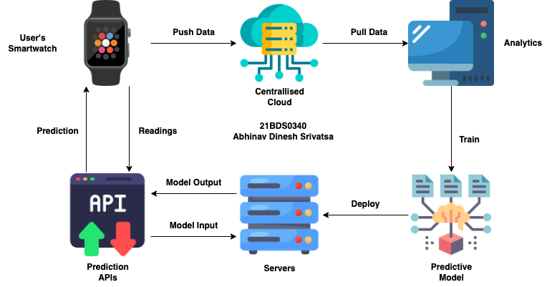

**User Smartwatches**

Contains various sensors to measure users’ data, sensors include:

* Heart rate monitors to measure heart rate
* Oximetry sensors to measure blood oxygen levels
* Ambient light sensors to measure surrounding lighting conditions
* Accelerometers to measure velocity and acceleration
* Gyroscopes to measure changes in direction angularly
* Barometers to measure atmospheric pressure
* Ambient temperature sensors to measure the environments temperature
* Magnetometer to measure nearby magnetic fields strengths and direction
* Skin conductance sensors to measure the skins electrical conductivity
* Skin temperature sensors to measure body temperature
* GPS (Global Positioning System) to measure current location globally

The smartwatch takes the data measured and pushes it to the cloud for analytics to use.

**Centrallised Cloud**

Pools data and store it to be used by analytics teams, technologies for stream processing will shine here.

**Analytics**

Uses data stored by the data ingestion in the cloud to perform exploratory data analysis and find patterns in data, model building and testing happens here.

**Predictive Model**

A model is developed by analysis of the data to create steady relationships between the independent variables and predicting (dependent) variable in the data.

**Servers**

The predictive model can be deployed on servers on the cloud or locally to allow users to be able to access predictions and test accuracy.

**Prediction APIs**

APIs can be developed for users to access the model in the servers with better security and rate limiting. This completes the cycle for predictions for users utilizing data that they have provided.

**Activity Recognition and Fitness Metrics**

**Activities Tracked**

1. Bicycling
2. Sitting/standing
3. Sleep
4. Vehicle travelling
5. Walking
6. Any other actions (mixed)

**Expected Deliverables start on the next page:**